www.upce.cz

"IMRAMOVSKÝ RESEARCH GROUP"
http://imramovsky.upce.cz/

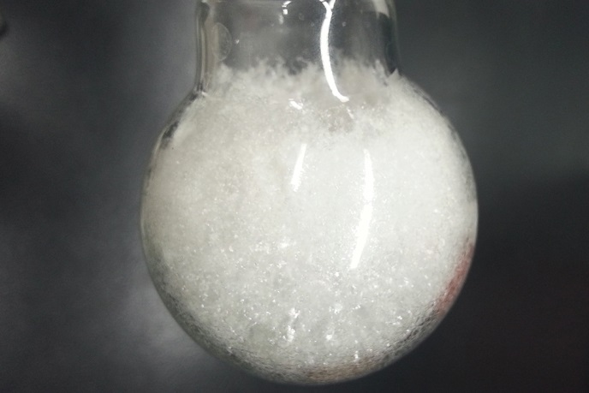

Our research is currently focused on the following topics
- Potential proteasome inhibitors based on salicylic amides – peptide scaffold.
- Development of new perspective technology veterinary prostaglandins.
- Prospective study of new abused substances with synthesis, metabolism and analytical tools for rapid screening in biological matrix.
- New materials with promising optical properties.

Are you interested in some of our research topics? ...
Do not hesitate to contact group leader or any other group member to get more information.

NEW POSITIONS IN 2018:
There is a possibility to accept one or two Erasmus-plus students in our group. They can make their diploma or research visit in our lab. The work is focused on the organic synthesis of biologically active compounds both in technology part or basic research. There is also possibility to accept one Ph.D. study student in research program Organic Chemistry or Organic technology (both are realised at our institute and A. Imramovský will be the supervisor).

It is also possible make a combination of Erasmus+ followed with Ph.D. study etc.

For latest news :
https://www.facebook.com/Imramovsk%C3%BD-Research-Group-524694714543002/

Dodatne informacije: Krištof Kranjc (FKKT, soba 2061); kristof.kranjc@fkkt.uni-lj.si

